**Unlicensed Grove Hall radio station shuttered**

**By Meghan E. Irons** Globe Staff, April 18, 2014, 12:56 a.m. **19**

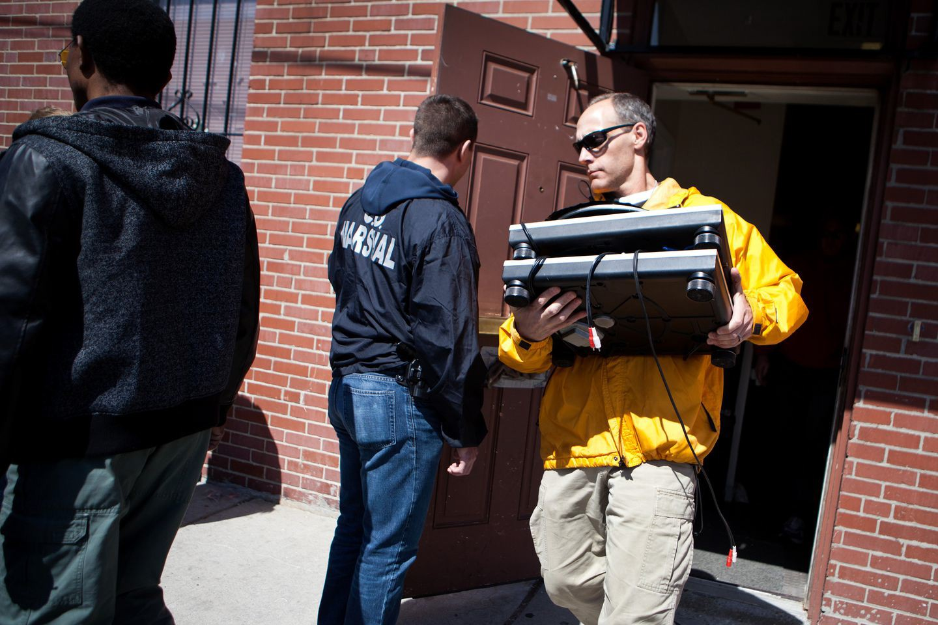

US marshals seized transmission equipment from TOUCH 106.1 FM in Boston’s Grove Hall neighborhood Thursday in a crackdown on unlicensed radio stations. KAYANA SZYMCZAK FOR THE BOSTON GLOBE

Federal agents shut down an unlicensed radio station in Grove Hall Thursday that is popular in the African-American community and seized transmission equipment in a crackdown on illegally operating stations, according to the US attorney’s Boston office.

In the past two days, authorities put the lid on TOUCH 106.1 FM and two other stations in Dorchester and Brockton, said Christina Sterling, spokeswoman for the US attorney.

Authorities said little about the other stations, but confirmed they opened a previous case against TOUCH and its founder, Charles L. Clemons Jr., after receiving a complaint last year that Clemons was using his station to promote his unsuccessful 2013 mayoral bid.

Advertisement



“Unlicensed broadcasting threatens the integrity of the regulatory structure established by the Communications Act to prevent chaos in the radio spectrum,’’ Federal Communications Commission official Vincent H. Bostic, who investigated the station, said in court documents.

News of the raid sent shockwaves through Boston’s African-American community, where the station filled a vacuum on the airwaves after the station WILD-AM was sold.

**Get Today's Headlines in your inbox** Enter Email

[example@email.com](mailto:example@email.com)

**Sign Up**

The day's top stories delivered every morning.

“It’s such a shame,’’ said Trina Smith, a 39-year-old Dorchester resident who tuned in regularly. “The station gave us information that you wouldn’t get unless you listened to it. Why do they want to shut it down?”

Clemons, 52, of Dorchester, appeared emotional but resolute Thursday, vowing “we will not be silenced” and saying he will fight the shutdown. He acknowledged running an unlicensed station, but said it “was the right thing to do’’ to fill a gap in the minority community. Obtaining a license to operate a station is expensive and often out of reach for many minority broadcasters, Clemons’s radio supporters said.

Clemons said his station helped raise money to feed the homeless, for families faced with the sudden burial of a relative, and for people struggling to find work.

Advertisement

“How can you with a conscious mind shut down . . . a positive radio station like this?” Clemons asked. “There is no other radio station like this in the city of the Boston.”

Station founder and host Charles Clemons (right) vowed to fight TOUCH 106.1 FM’s closing. KAYANA SZYMCZAK FOR THE BOSTON GLOBE/GLOBE FREELANCE

Known as “Brother Charles,’’ Clemons is the soothing voice on “The Morning Show,” which he hosted 6 to 10 a.m. weekdays with sidekick “Sunshine.”

He founded the station in 2007, calling it the fabric of the black community and attracting politicians of all stripes eager to get their message out to listeners along the spine of Blue Hill Avenue.

In addition to soulful and other music popular in the black community, the station was a sounding board for listeners concerned about diversity in city government, rampant shootings, and the chronic employment gap.

“If you want to know what is going on in this community, the only station that will let you do that is TOUCH 106.1 FM,’’ said Arthur Weeks of Roxbury.

Mayor Martin J. Walsh refrained from commenting on specifics about the shutdown, citing the investigation. “The mayor recognizes and understands the value that the medium of communication provides to the community, and he will continue to work with community leaders to assess the situation going forward,’’ said spokeswoman Kate Norton.

The 100-watt station is in Grove Hall, at 5 Cheney St. Its owners are listed as Leroy McLauren and John Laing, who did not respond to a request for comment Thursday. The station is in the basement of a nonprofit run by Clemons’s mother.

Advertisement

In court documents, US authorities detail their efforts to gain access to the station and their attempts to get Clemons to respond to inquiries.

In 2008, the FCC slapped Clemons and the station with a $17,000 fine for willfully running an illegal radio station. A US District Court judge issued a summary judgment against Clemons in February 2012 for not paying the fine.

“Mr. Clemons neither appealed the forfeiture order nor paid the $17,000 forfeiture,’’ court documents said.

In August 2013, the US attorney launched another investigation after receiving a complaint that Clemons was using the station to promote his mayoral campaign, documents said.

And in March, after numerous attempts to gain entry to the station, federal authorities sent a warrant with a warning by certified mail to Clemons, McLaren, Laing, and the Neighborhood Development Corp. of Grove Hall, where Clemons’s mother, Virginia Morrison, is executive director.

On Thursday, Clemons said he had finished his radio show when federal marshals knocked on the front door. They had come to seize all radio station transmission equipment, antennae, radio frequency power amplifiers, radio frequency test equipment, and other devices used to transmit signals.

“This is not the end of it,’’ Clemons said. “I’m going to fight. If we have to go to President Obama to do the right thing, then we are going to do that.’’

[Meghan E. Irons can be reached at meghan.irons@globe.com.](mailto:MeghanE.Ironscanbereachedatmeghan.irons@globe.com)

**Show 19 comments**

# BOSTON GLOBE VIDEO

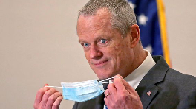

2:23

Baker announces ‘VaxMillions’ lottery program SHARE

Governor Charlie Baker announced residents who are fully vaccinated against COVID-19 will have the chance to win $1 million in a special Lottery sweepstakes. (Photo by Matt Stone/Boston Herald via AP)

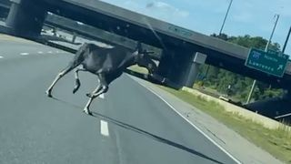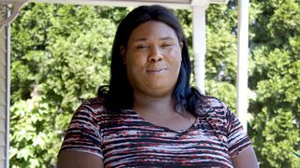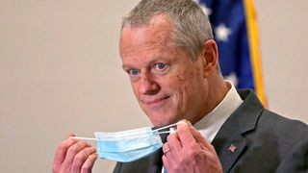

**Baker announces ‘VaxMillions’ lottery program**

**NOW PLAYING**

**Moose spotted on Route 3 in Chelmsford**

**What Black liberation means to me: Athena Vaughn**

**SEE MORE VIDEOS**

**MOST POPULAR ON BOSTONGLOBE.COM**

1. Life sciences is poised to be Boston’s dominant industry. Has the area become the Silicon Valley of biotech?
2. Some lawmakers want to ban critical race theory in schools. So, what is it?
3. How Massachusetts communities are celebrating the state’s first official Juneteenth
4. Is there something wrong with the air in South Portland, Maine?
5. Message in a bottle, tossed into the sea in Rhode Island, found in Azores
6. ‘My Name Is Bulger’: Two brothers, one documentary, an only-in-Boston story
7. Coolidge Corner Theatre gets go-ahead for major expansion
8. A power play? Steam plant owner aims to decarbonize downtown with huge building project
9. Baker announces ‘VaxMillions’ lottery program, offering $1 million cash prizes to boost vaccination rates
10. UMass Lowell to remain closed Wednesday while investigating ‘cybersecurity incident’



**VIEWS FROM OUR COLUMNISTS**

**YVONNE ABRAHAM**

Energy efficiency is a low-hanging fruit to combat climate change. So why can’t everyone get access to it?

**KEVIN CULLEN**

Bill Bratton on American policing and the challenge facing the Boston Police Department

**THOMAS FARRAGHER**

A salute across the ages to an old squad leader

**SHIRLEY LEUNG**

A working mother’s manifesto: Pandemic provides a once-in-a-generation chance to course correct how we work

**JENEÉ OSTERHELDT**

The pride I carry with me: Karim

**ADRIAN WALKER**

‘The best Boston movie no one’s ever seen’: ‘Blue Hill Avenue’ at 20

**MORE ON GLOBE.COM**

# SPONSORED BY: SUB- ZERO, WOLF, AND COVE

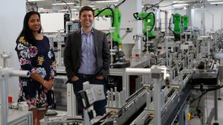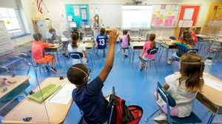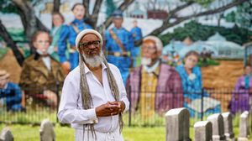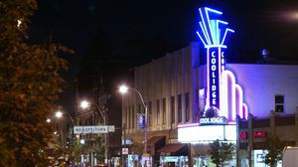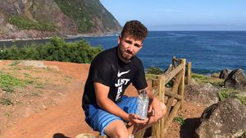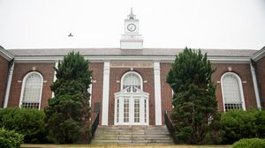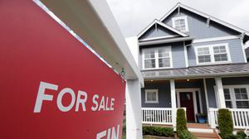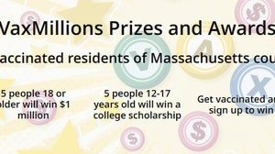

## Outfit your designer kitchen with this guide to high-end appliances

From choosing a cooktop to refrigeration options, learn how to select the right style for your space.

# INNOVATION ECONOMY

## Life sciences is poised to be Boston’s dominant industry. Has the area become the Silicon Valley of biotech?

Since December, you can find six major indications that Boston is the undisputed center of the life sciences industry, a place where ideas and products that change — and save — people’s lives around the world originate.

# THE GREAT DIVIDE

## Some lawmakers want to ban critical race theory in schools. So, what is it?

As national debate over race-related curriculums rages on, here is a lesson on the subject and the controversy surrounding it.

## How Massachusetts communities are celebrating the state’s first official Juneteenth

For more than a century, Juneteenth was a Texan holiday, then a Southern holiday, commemorating the anniversary of June 19, 1865, when General Gordon Granger of the Union Army told formerly enslaved people in Galveston they were free. Now it will be celebrated for the first time across the Commonwealth as an official state holiday.

# GLOBE MAGAZINE

## Is there something wrong with the air in South Portland, Maine?

Residents have lived near more than 100 massive petroleum storage tanks for decades, never really knowing if they’re breathing in dangerous chemicals. Now they’re fighting to find out.

## Coolidge Corner Theatre gets go-ahead for major expansion

Brookline officials are reviewing a proposed expansion of the landmark Art Deco cinema that will add two new screens — and over 200 seats — as well as a larger lobby and third-floor community space, with a catering kitchen and outdoor roof deck.

# RI NEWS

## Message in a bottle, tossed into the sea in Rhode Island, found in Azores

The note was written in 2018 by a 13- year-old who was visiting family in Rhode Island.

## UMass Lowell to remain closed Wednesday while investigating ‘cybersecurity incident’

The University of Massachusetts Lowell was forced to cancel all in- person and remote classes Tuesday and Wednesday “due to an IT outage,” the university said.

## Too hot? Sky-high prices may be scaring some buyers away from the housing market

A real estate trade group said Wednesday that there are some signs that the blistering seller’s market may be softening modestly after months of rising values.

## Baker announces ‘VaxMillions’ lottery program, offering $1 million cash prizes to boost vaccination rates

State officials on Tuesday said residents who are fully vaccinated against COVID-19 will have the chance to win $1 million in a special Lottery sweepstakes.

**MOST READ IN THIS SECTION**

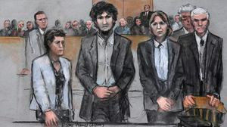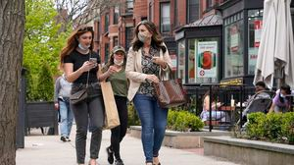

**THE GREAT DIVIDE**

**Some lawmakers want to ban critical race theory in schools. So, what is it?**

**GLOBE MAGAZINE**

**Is there something wrong with the air in South Portland, Maine?**

**RI NEWS**

**Message in a bottle, tossed into the sea in Rhode Island, found in Azores**

**How Massachusetts**

**communities are celebrating the state’s first official Juneteenth**

**Death penalty should be**

**reinstated for Tsarnaev in Boston Marathon bombings case, Biden administration tells Supreme Court**

**UMass Lowell to remain**

**closed Wednesday while investigating ‘cybersecurity incident’**

**Baker announces**

**‘VaxMillions’ lottery program, offering $1 million cash prizes to boost vaccination rates**

**The downside of ditching**

**masks: the return of colds, flu**

# FOLLOW US

**SUBSCRIBE NOW MY ACCOUNT CONTACT MORE**

Digital Access / Home Delivery / Gift Subscriptions

Log In /

Manage My Account / Customer Service

Help & FAQs / Globe Newsroom / Advertise

Newsletters / View The EPaper /

Order Back Issues / News In Education / Search The Archives / Privacy Policy / Terms Of Service / Terms Of Purchase / Work At Boston Globe Media /

Do Not Sell My Personal Information



**METRO SPORTS BUSINESS & TECH OPINION**

WELCOME, JOHN

**TODAY'S PAPER**

**Summer Fitness Challenge**

**Starts Monday**

Sign up now

©2021 Boston Globe Media Partners, LLC